HI,

Please find below my understanding based of my experience- project’s which I had come

across with respect to Docusign / adobe e-sign integration with CRM.

**Docusign Flow explained----**

1. Docusign is basically a connector which serves as a bridge between CRM and Target User’s/ Signers. This connector consists of a Managed package/ Solutions in SFDC or Microsoft CRM.
2. Each Docusign User(admin User) has to have a licenses in order to access all the available components (Classes, methods, Objects) which is managed via Licenses & Permission sets in any CRM.
3. Each Account subscribing to Docusign service gets’ an admin account- (similar to someone registering to Google in order to avail its services). Unique account # which they can access via any browser.
4. This Docusign Admin account stores all the critical information- Org ID for the CRM, Account Name, Access Token- which you can use to connect your CRM with Docusign, Docusign Tags, Stored Documents, Rules and so on.
5. Login Screen to the Admin Guide.
6. 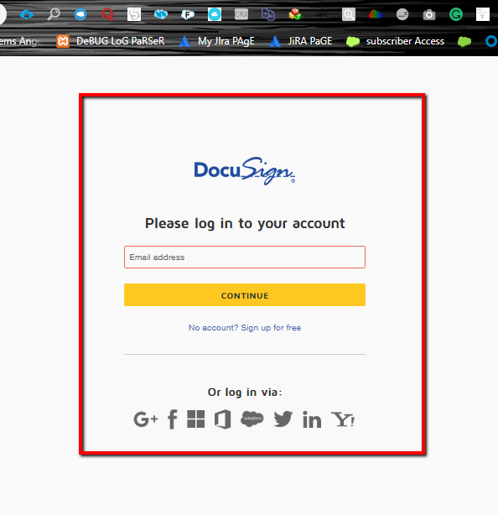
7. Post Login – You can manage your accounts’ via the Manage Carousel

T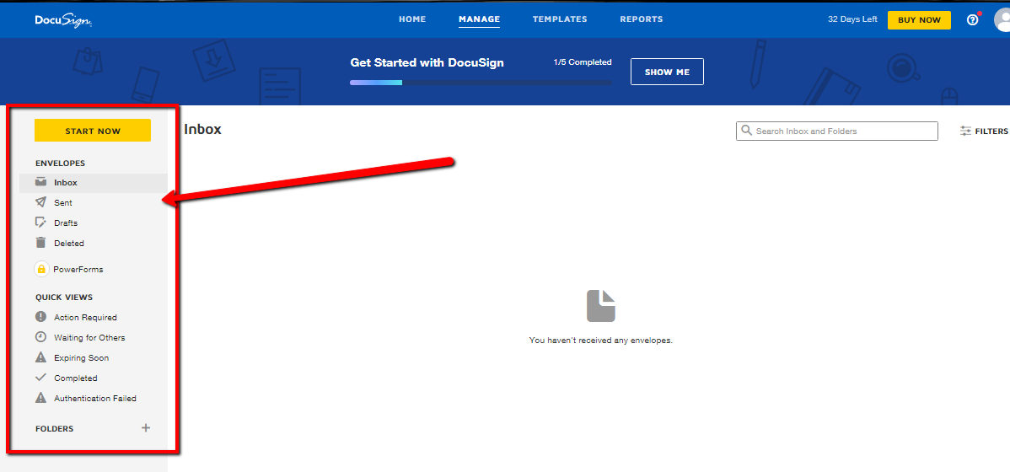

1. Create New Templates or Import Templates (Terms and conditions) in the Docusign admin.

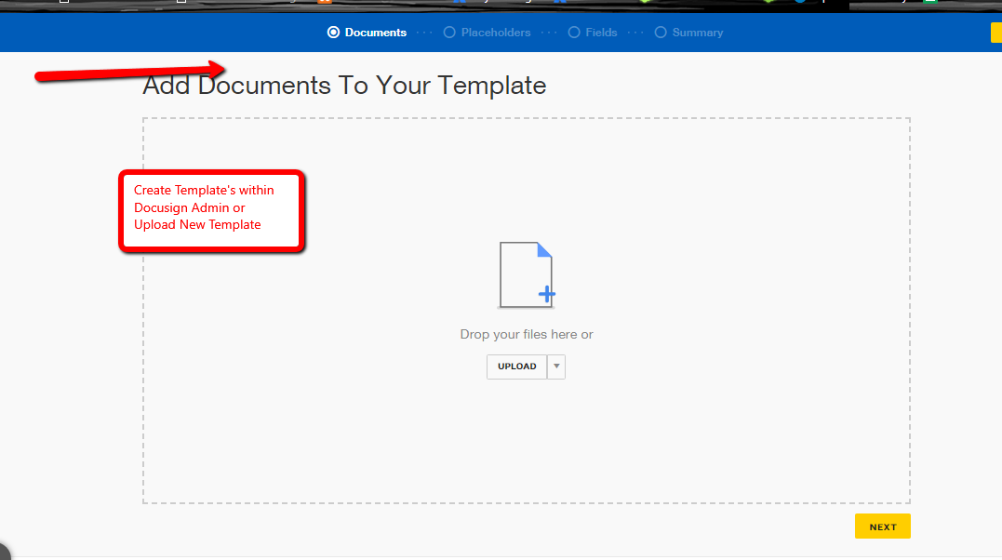

1. This template is utilized and is attached when you click on the e-signature button on the quote which re-directs the page to the email this email page is Docusign provided page where user enters the client’s email address below the page it also consists the envelop which consists the quote template and other templates’ which are pulled from your account through your admin user login.
2. 
3. 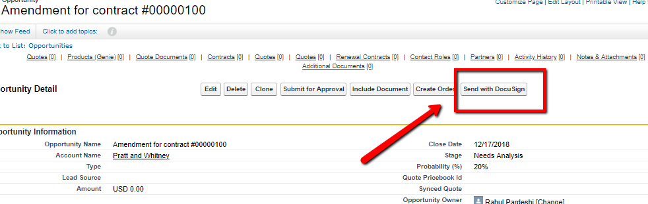
4. 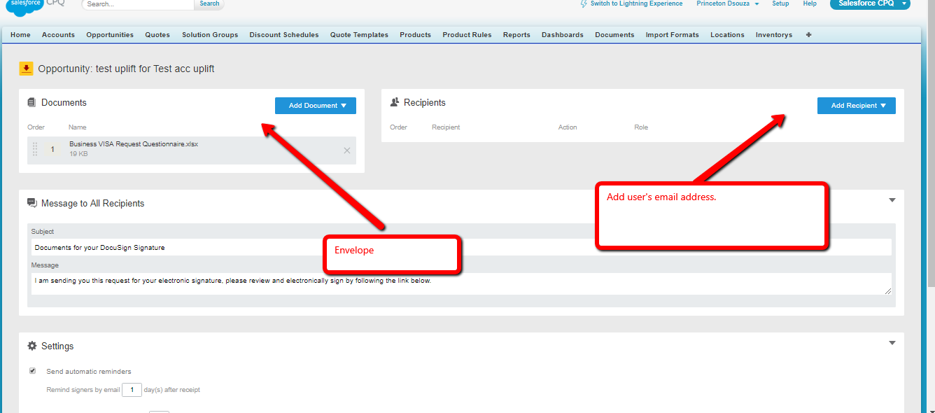
5. 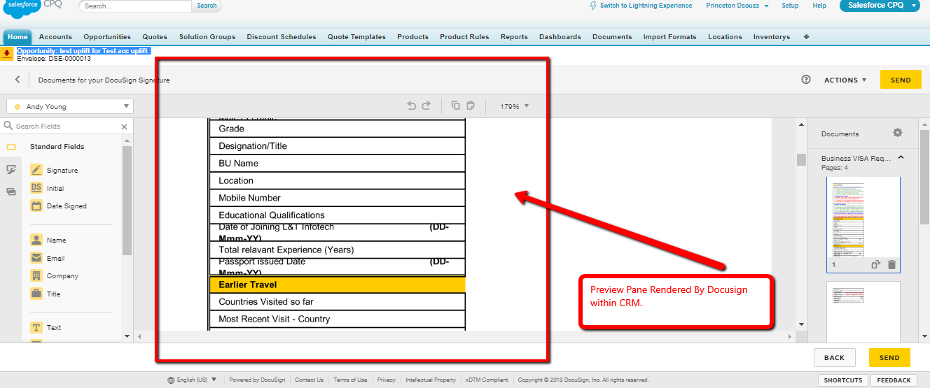
6. 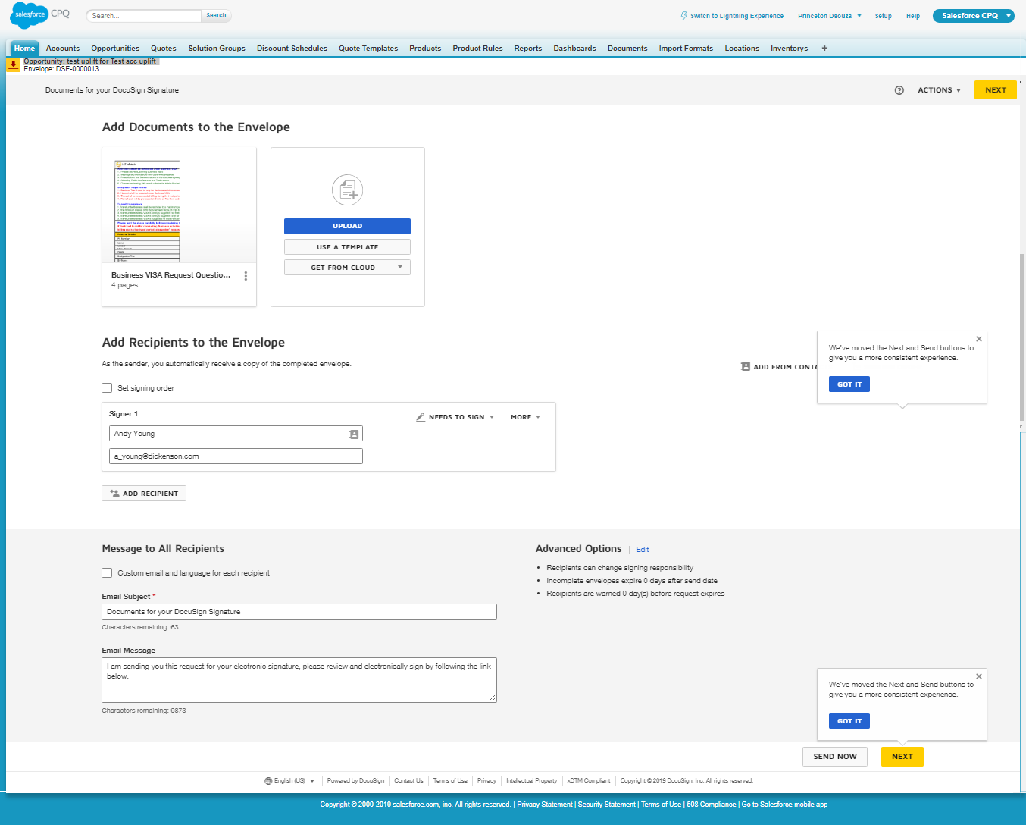

Add the account name and the user’s email address – this is prepopulated via CRM – users’ list

1. 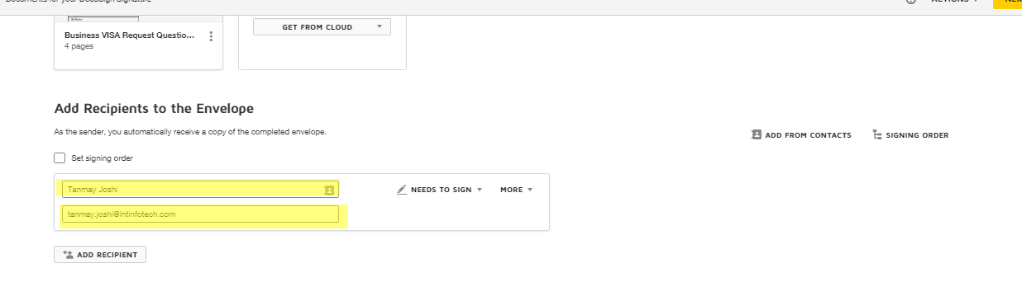

Email Received via Docusign with the link for the document which opens’ up a document console in web and client gets the ability to sign the document on the fly.

1. 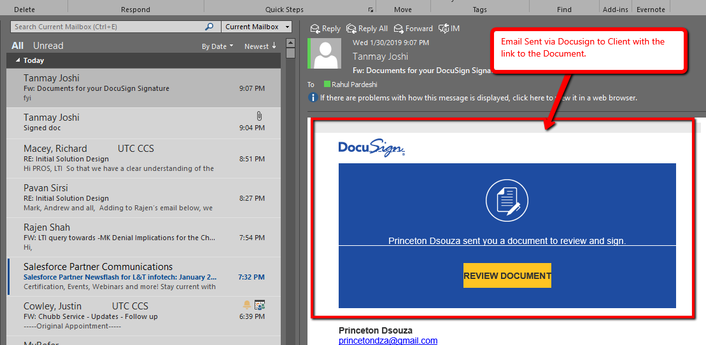
2. Client as soon as he / she signs the document following the above link the sender’s gets a notification letting them know the document got signed.

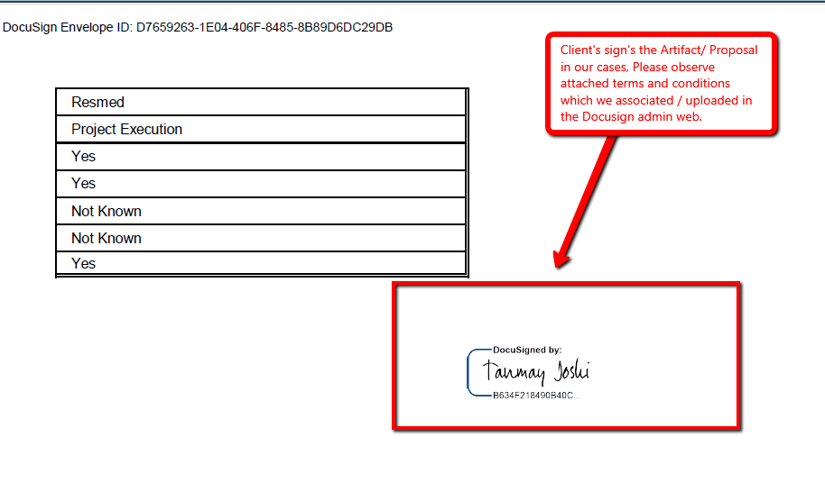

1. Although, the signed document’s stays in the admin login console/ repository for DocuSign – web access. You can create a rule with the admin console which will route back the singed document to quote entity within CRM.